ASTA Policy and Leadership Development Conference
Washington D.C.
June 20-23, 2021
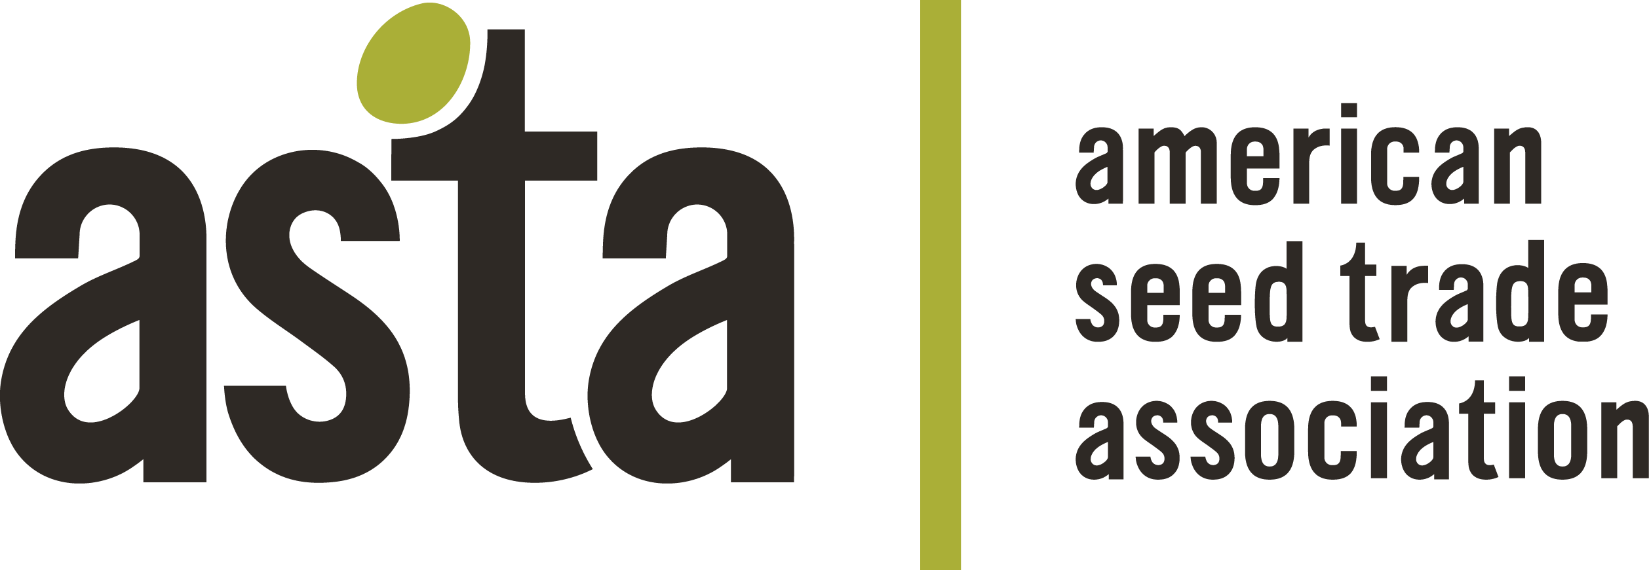

Phytosanitary Session: Seed Health Testing & Impacts
3:00 PM-3:45 PM | June 21, 2021 | Grand Hyatt, Constitution Ballroom A/B

AGENDA

 | Topic | Presenter | Time
I. | Welcome, Speaker Introductions, ASTA Antitrust Compliance Policy Statement | Scott Heuchelin, Corteva  Chair, ASTA Phytosanitary Committee | 3:00 PM
II. | Phytosanitary Outlook: Seed Health Testing and Its Impacts | Osama El-Lissy, Deputy Administrator, APHIS PPQ | 3:05 PM
III. | Panel Discussion: Policy and Technology Challenges, Impacts on Seed Movements, Research Needs, Future Opportunities | Ric Dunkle (Moderator)  Scott Heuchelin, Corteva  Rick Winn, HM Clause  Samantha Thomas, Bayer  Kevin Ong, TAMU  Gary Munkvold, Iowa State  Vessela Macrodieva, APHIS | 3:25 PM
IV. | Adjourn |  | 3:45 PM

ASTA Antitrust Compliance Policy Statement

It is the policy of the American Seed Trade Association to comply strictly with the Federal and State antitrust laws. ASTA’s policy and guidelines, to ensure compliance with both the letter and spirit of the laws, are set forth in ASTA’s bylaws.

The antitrust laws prohibit combinations or conspiracies in restraint of trade. This means that competitors may not legally agree to conduct that inhibits competition. Anticompetitive agreements may be inferred from discussions about sensitive topics. Because trade associations like ASTA bring competitors together to address industry concerns, we must be especially careful not to agree to actions that might be interpreted as anticompetitive.

It is ASTA policy to have written agendas for all meetings, to have legal counsel present where sensitive issues might be discussed, and to prepare minutes of all meetings. This applies to all meetings held during a conference hosted by ASTA. If you have any questions about the proper scope of any ASTA meeting, or the Association’s antitrust compliance policy, please raise it with the meeting chairperson or member of ASTA staff.

