ASTA’s Leadership Summit
Growing Leaders
Sacramento, CA
June 10-14, 2023
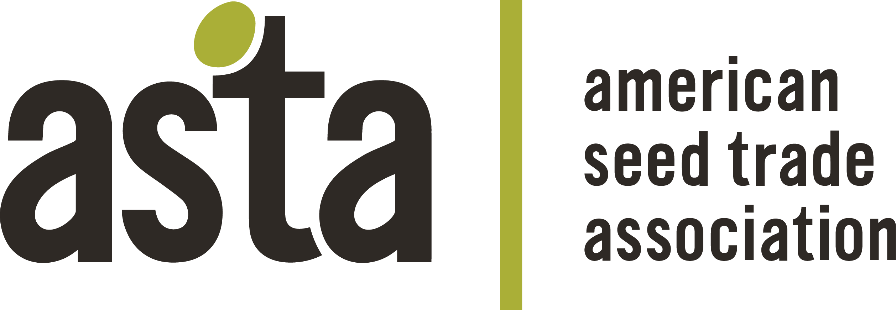

Phytosanitary Session: How to Build a Resilient Seed Supply
1:00 P.M. – 2:30 P.M. | June 11, 2023 | Golden State AB

AGENDA

 | Welcome, Introductions, ASTA Antitrust Policy | Samantha Thomas (Bayer Crop Sciences), Chair | 1:00 P.M.
I. | Building a Resilient Seed Supply: Phytosanitary Certification Challenges:  - Seed health testing  - Biological relevance  - Testing offshore vs. onshore  - Methods development/validation  - Use of Systems Approach (ReFreSH)  - Future trends and needs | Small Group Breakout Discussions  Moderators: Samantha Thomas (Bayer Crop Sciences) and Yilmaz Balci (APHIS) | 1:05 P.M.
II. | Building a Resilient Seed Supply: Real World Issues:  - High plains virus and corn seed  - Federal orders (ToBRFV, pospiviroids)  - Phytosanitary capacity (technical, human) | Small Group Breakout Discussions  Moderators: Cheni Filios (Ball Hort), Tracy Bruns (APHIS) | 1:45 P.M.
III. | What Does ASTA do to Support These Issues?  - Provide Expertise, Coordination  - Leadership  - Research support (ASRF, SSF, Other) | Moderators: Samantha Thomas, Ric Dunkle (ASTA) | 2:10 P.M.
IV. | Summary Discussion | Workshop Participants | 2:25 P.M.
V. | Adjourn |  | 2:30 P.M.

ASTA Antitrust Compliance Policy Statement

It is the policy of the American Seed Trade Association to comply strictly with the Federal and State antitrust laws. ASTA’s policy and guidelines, to ensure compliance with both the letter and spirit of the laws, are set forth in ASTA’s bylaws.

The antitrust laws prohibit combinations or conspiracies in restraint of trade. This means that competitors may not legally agree to conduct that inhibits competition. Anticompetitive agreements may be inferred from discussions about sensitive topics. Because trade associations like ASTA bring competitors together to address industry concerns, we must be especially careful not to agree to actions that might be interpreted as anticompetitive.

It is ASTA policy to have written agendas for all meetings, to have legal counsel present where sensitive issues might be discussed, and to prepare minutes of all meetings. This applies to all meetings held during a conference hosted by ASTA. If you have any questions about the proper scope of any ASTA meeting, or the Association’s antitrust compliance policy, please raise it with the meeting chairperson or member of ASTA staff.

